Non-iid datasets

%non-iid = 0

Client1 shape: (5939, 2)

Client2 shape: (6003, 2)

Client3 shape: (5945, 2)

Client4 shape: (6018, 2)

Client5 shape: (6139, 2)

Client6 shape: (6093, 2)

Client7 shape: (6009, 2)

Client8 shape: (5938, 2)

Client9 shape: (5947, 2)

Client10 shape: (5969, 2)

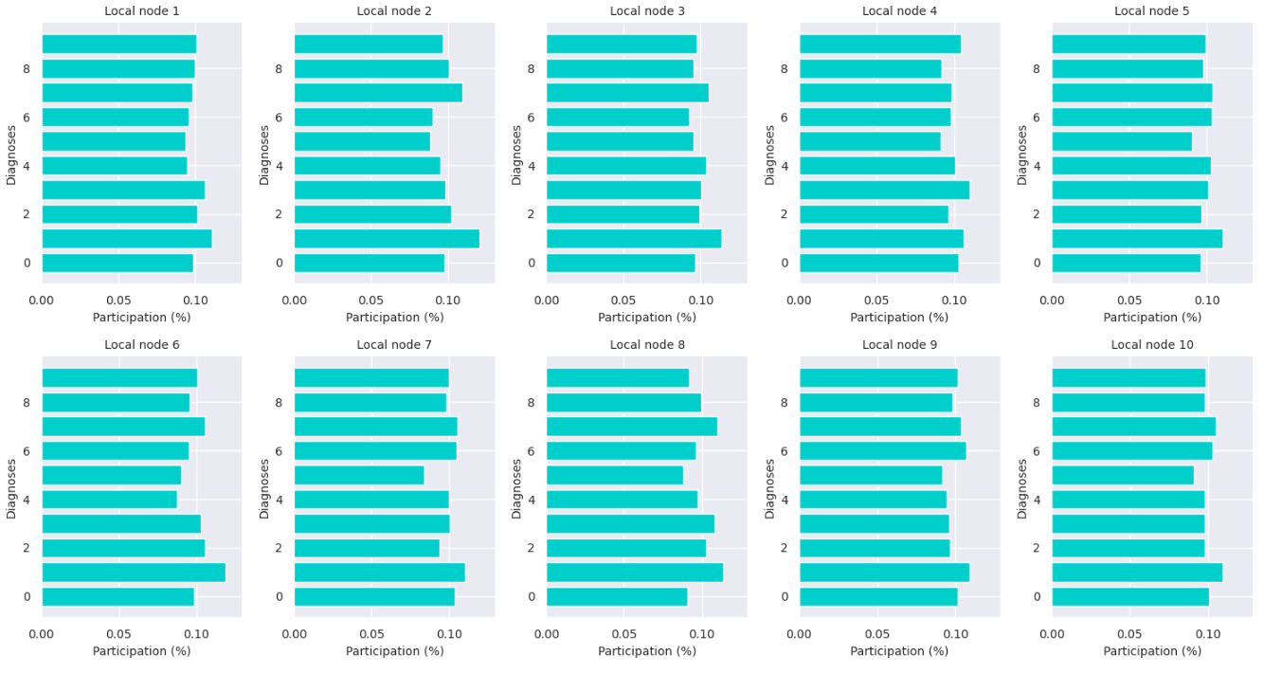

Jensen-Shannon distance: 0.018035466885805075

Hellinger distance: 0.020410922270009842

Earth Mover’s distance: 0.04712225401564925

%non-iid = 10

Client1 shape: (5961, 2)

Client2 shape: (6144, 2)

Client3 shape: (6005, 2)

Client4 shape: (6047, 2)

Client5 shape: (6024, 2)

Client6 shape: (5944, 2)

Client7 shape: (6022, 2)

Client8 shape: (6030, 2)

Client9 shape: (5886, 2)

Jensen-Shannon distance: 0.23698902859051496

Hellinger distance: 0.248099035488497

Earth Mover’s distance: 0.0625565696936396

%non-iid = 20

Client1 shape: (5936, 2)

Client2 shape: (6228, 2)

Client3 shape: (5991, 2)

Client4 shape: (6090, 2)

Client5 shape: (6006, 2)

Client6 shape: (5844, 2)

Client7 shape: (5982, 2)

Client8 shape: (6034, 2)

Client9 shape: (5888, 2)

Client10 shape: (6001, 2)

Jensen-Shannon distance: 0.33514608933844575

Hellinger distance: 0.3434311176541731

Earth Mover’s distance: 0.06680687911251836

%non-iid = 30

Client1 shape: (5936, 2)

Client2 shape: (6228, 2)

Client3 shape: (5991, 2)

Client4 shape: (6090, 2)

Client5 shape: (6006, 2)

Client6 shape: (5844, 2)

Client7 shape: (5982, 2)

Client8 shape: (6034, 2)

Client9 shape: (5888, 2)

Jensen-Shannon distance: 0.33514608933844575

Hellinger distance: 0.3434311176541731

Earth Mover’s distance: 0.06680687911251836

%non-iid = 40

Client1 shape: (5905, 2)

Client2 shape: (6316, 2)

Client3 shape: (5979, 2)

Client4 shape: (6132, 2)

Client5 shape: (6003, 2)

Client6 shape: (5826, 2)

Client7 shape: (5960, 2)

Client8 shape: (5985, 2)

Client9 shape: (5861, 2)

Jensen-Shannon distance: 0.43010410953892964

Hellinger distance: 0.43336847990166716

Earth Mover’s distance: 0.06723499533899184

%non-iid = 50

Client1 shape: (5935, 2)

Client2 shape: (6432, 2)

Client3 shape: (5968, 2)

Client4 shape: (6094, 2)

Client5 shape: (5943, 2)

Client6 shape: (5766, 2)

Client7 shape: (5935, 2)

Client8 shape: (6030, 2)

Client9 shape: (5886, 2)

Client10 shape: (6011, 2) 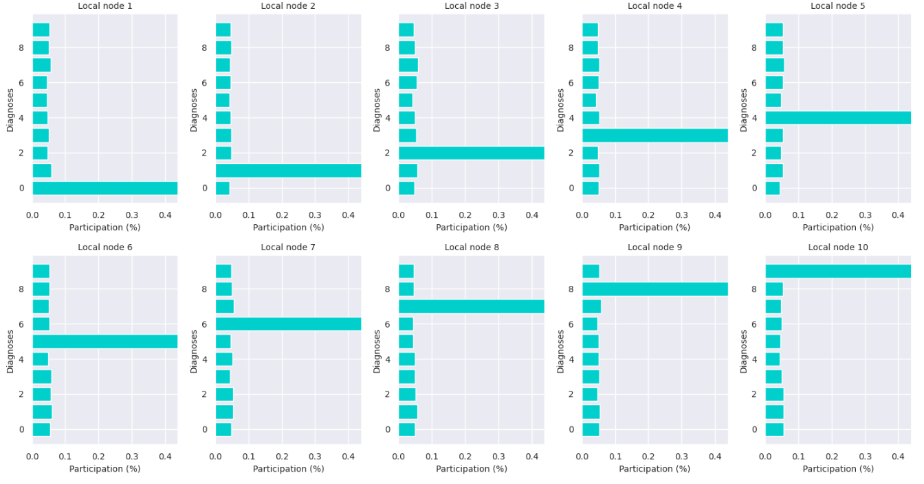

Jensen-Shannon distance: 0.5189386292375957

Hellinger distance: 0.5161171280965186

Earth Mover’s distance: 0.0675364485790898

%non-iid = 60

Client1 shape: (5940, 2)

Client2 shape: (6520, 2)

Client3 shape: (5945, 2)

Client4 shape: (6118, 2)

Client5 shape: (5903, 2)

Client6 shape: (5688, 2)

Client7 shape: (5927, 2)

Client8 shape: (6051, 2)

Client9 shape: (5856, 2)

Jensen-Shannon distance: 0.6107359242722341

Hellinger distance: 0.6004812165582928

Earth Mover’s distance: 0.06215574450359549

%non-iid = 70

Client1 shape: (5949, 2)

Client2 shape: (6601, 2)

Client3 shape: (5925, 2)

Client4 shape: (6089, 2)

Client5 shape: (5896, 2)

Client6 shape: (5625, 2)

Client7 shape: (5972, 2)

Client8 shape: (6083, 2)

Client9 shape: (5832, 2)

Client10 shape: (6028, 2)

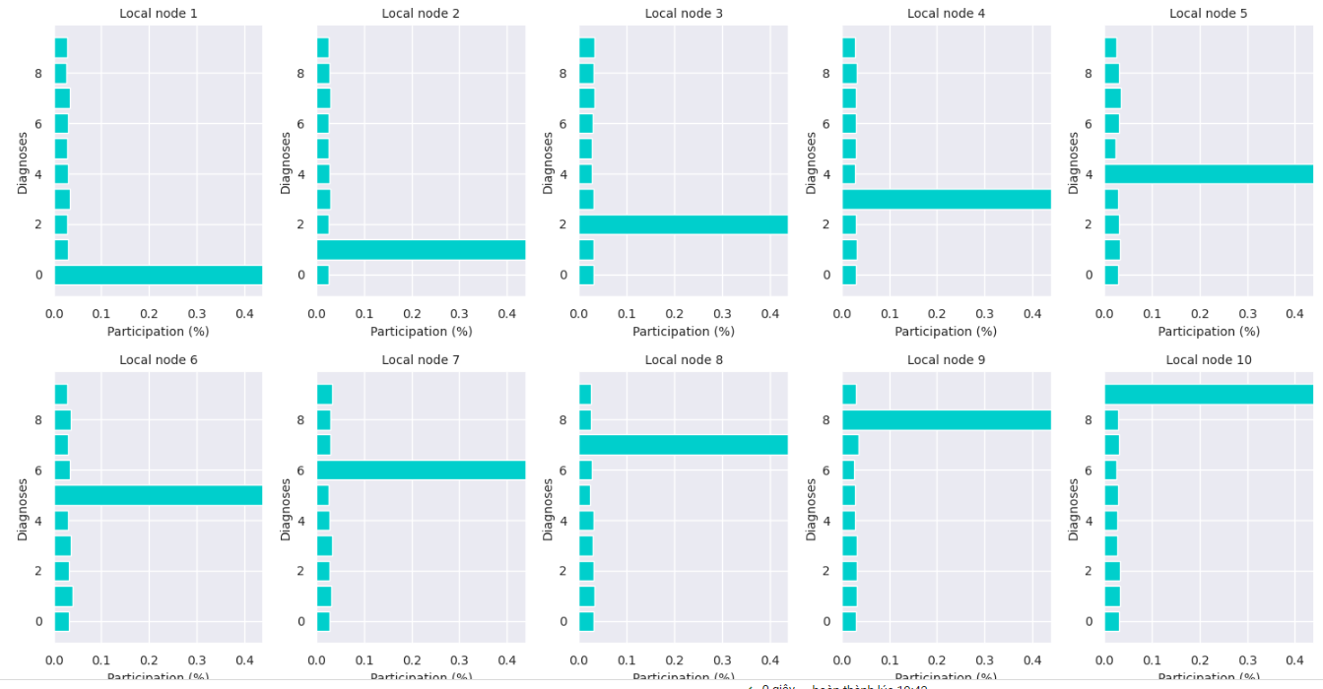

Jensen-Shannon distance: 0.6994519604345264

Hellinger distance: 0.681549876513208

Earth Mover’s distance: 0.05710839765409577

%non-iid = 80

Client1 shape: (5906, 2)

Client2 shape: (6695, 2)

Client3 shape: (5932, 2)

Client4 shape: (6100, 2)

Client5 shape: (5823, 2)

Client6 shape: (5547, 2)

Client7 shape: (5919, 2)

Client8 shape: (6139, 2)

Client9 shape: (5901, 2)

Client10 shape: (6038, 2)

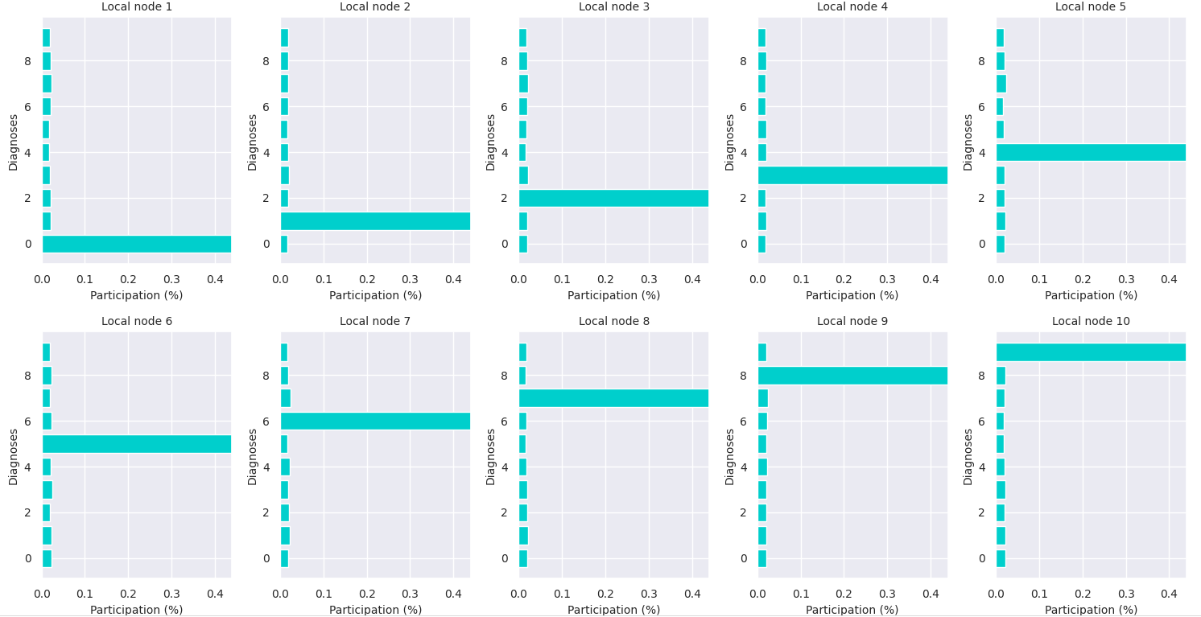

Jensen-Shannon distance: 0.7899026092594189

Hellinger distance: 0.7645881074749187

Earth Mover’s distance: 0.050265812701560636

%non-iid = 90

Client1 shape: (5937, 2)

Client2 shape: (6741, 2)

Client3 shape: (5914, 2)

Client4 shape: (6130, 2)

Client5 shape: (5839, 2)

Client6 shape: (5472, 2)

Client7 shape: (5932, 2)

Client8 shape: (6183, 2)

Client9 shape: (5867, 2)

Client10 shape: (5985, 2)

Jensen-Shannon distance: 0.8848653792459713

Hellinger distance: 0.8543714153292652

Earth Mover’s distance: 0.03669041306749981

%non-iid = 100

Client1 shape: (5923, 2)

Client2 shape: (6742, 2)

Client3 shape: (5958, 2)

Client4 shape: (6131, 2)

Client5 shape: (5842, 2)

Client6 shape: (5421, 2)

Client7 shape: (5918, 2)

Client8 shape: (6265, 2)

Client9 shape: (5851, 2)

Client10 shape: (5949, 2)

Jensen-Shannon distance: 1.0

Hellinger distance: 1.0

Earth Mover’s distance: 0.0